**RESULTS:**

**FLOWCHART OF THE PROPOSED WORK**

Diabetes Dataset

Preprocessing

Classiification Algorithm

Results

**CHART OF THE DATASET**

**(RED- DIABETES, BLUE- NO DIABETES)**

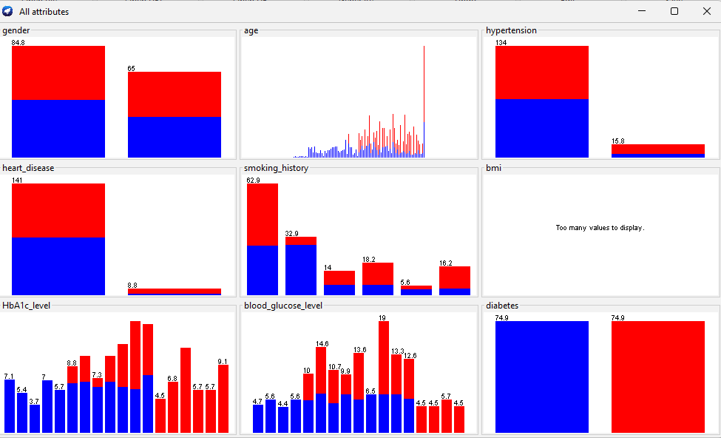

**NAVIE BAYES ALGORITHM RESULTS**

=== Evaluation on test split ===

Time taken to test model on test split: 0.01 seconds

=== Summary ===

Correctly Classified Instances 40.7482 85.8894 %

Incorrectly Classified Instances 6.6944 14.1106 %

Kappa statistic 0.7153

Mean absolute error 0.2305

Root mean squared error 0.3366

Relative absolute error 45.9252 %

Root relative squared error 67.0042 %

Total Number of Instances 47.4426

=== Detailed Accuracy By Class ===

TP Rate FP Rate Precision Recall F-Measure MCC ROC Area PRC Area Class

0.873 0.158 0.869 0.873 0.871 0.715 0.914 0.920 0

0.842 0.127 0.847 0.842 0.844 0.715 0.914 0.916 1

Weighted Avg. 0.859 0.144 0.859 0.859 0.859 0.715 0.914 0.918

=== Confusion Matrix ===

a b <-- classified as

22.59 3.29 | a = 0

3.4 18.16 | b = 1

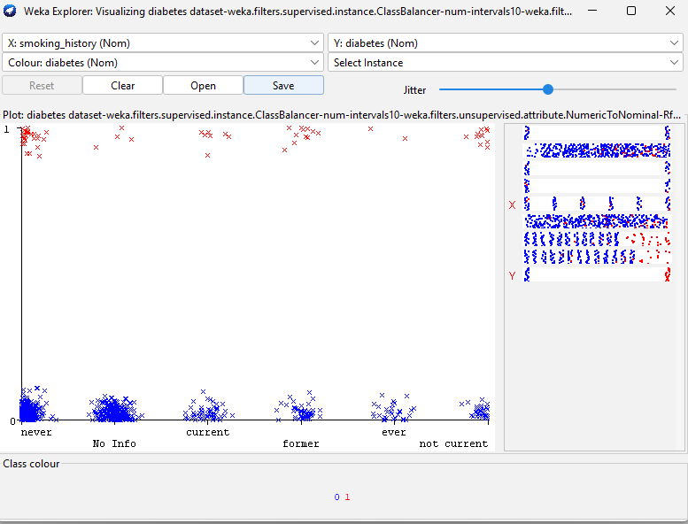

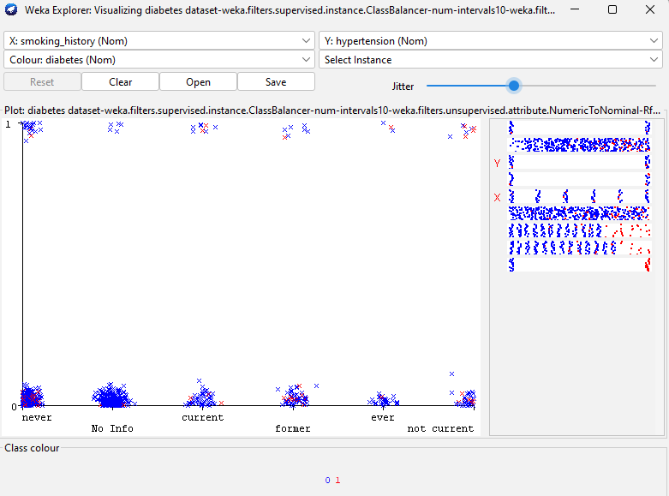

**RANDOM FOREST ALGORITHM RESULTS**

Time taken to build model: 0.24 seconds

=== Evaluation on test split ===

Time taken to test model on test split: 0.02 seconds

=== Summary ===

Correctly Classified Instances 29.948 63.1247 %

Incorrectly Classified Instances 17.4946 36.8753 %

Kappa statistic 0.2201

Mean absolute error 0.4339

Root mean squared error 0.4684

Relative absolute error 86.4479 %

Root relative squared error 93.2532 %

Total Number of Instances 47.4426

=== Detailed Accuracy By Class ===

TP Rate FP Rate Precision Recall F-Measure MCC ROC Area PRC Area Class

0.894 0.684 0.611 0.894 0.726 0.261 0.698 0.714 0

0.316 0.106 0.713 0.316 0.438 0.261 0.698 0.713 1

Weighted Avg. 0.631 0.421 0.657 0.631 0.595 0.261 0.698 0.714

=== Confusion Matrix ===

a b <-- classified as

23.14 2.74 | a = 0

14.75 6.81 | b = 1

